Sample source document for demo upload — this is the kind of Word document MGGS could provide for an Information Exchange article.

Announcements and Celebrations
Update from our Community
Compiled by — Clare Fitzgerald — Community Engagement Manager
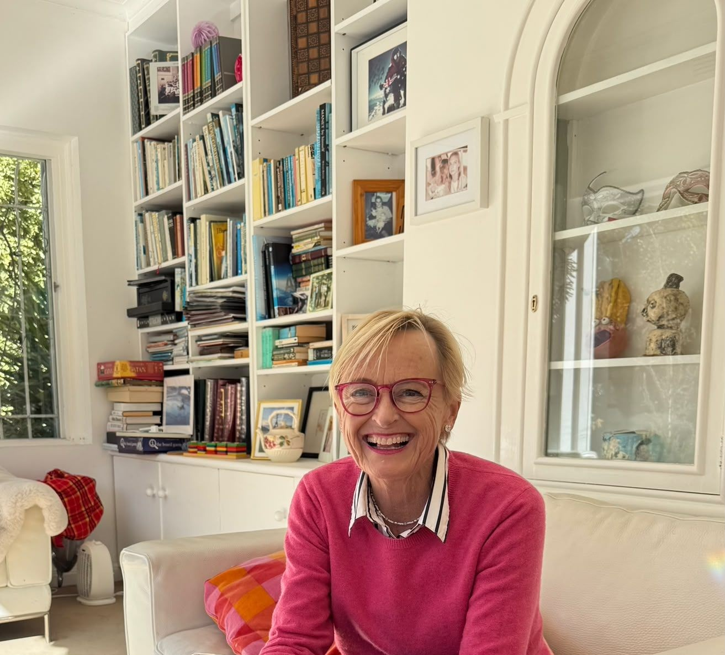
Vale Professor Katie Allen AO (Stephens, 1983) 24 February 1966 – 23 December 2025
Strong sense of community accompanies our Grammarians from their very first day at the School and remains with them long after they have departed. By sharing achievements, announcements and updates about both current and past Grammarians through Information Exchange, we maintain these valued connections.
We always appreciate hearing about the successes and milestones of our Old Grammarians. Every achievement and every life journey deserve recognition and celebration.
If you would like to share an update about an Old Grammarian or former staff member for inclusion in IE, please email community@mggs.vic.edu.au.

Births
- Elisa Huynh (2006) and Dimitrios Georgiou welcomed son Spiridon Duc Georgiou on 29 December 2025. His big sister Mikayla adores him very much!
- Lucy James (2012) and Bernie McLeod are proud to announce the birth of Fergus Christopher McLeod, born on February 23 weighing 3.8kg. He is already very loved, especially by his big brother Rupert.
- Lily Tribe (Langford, 2014) and husband Hugo welcomed baby Rupert on 29 December 2025.
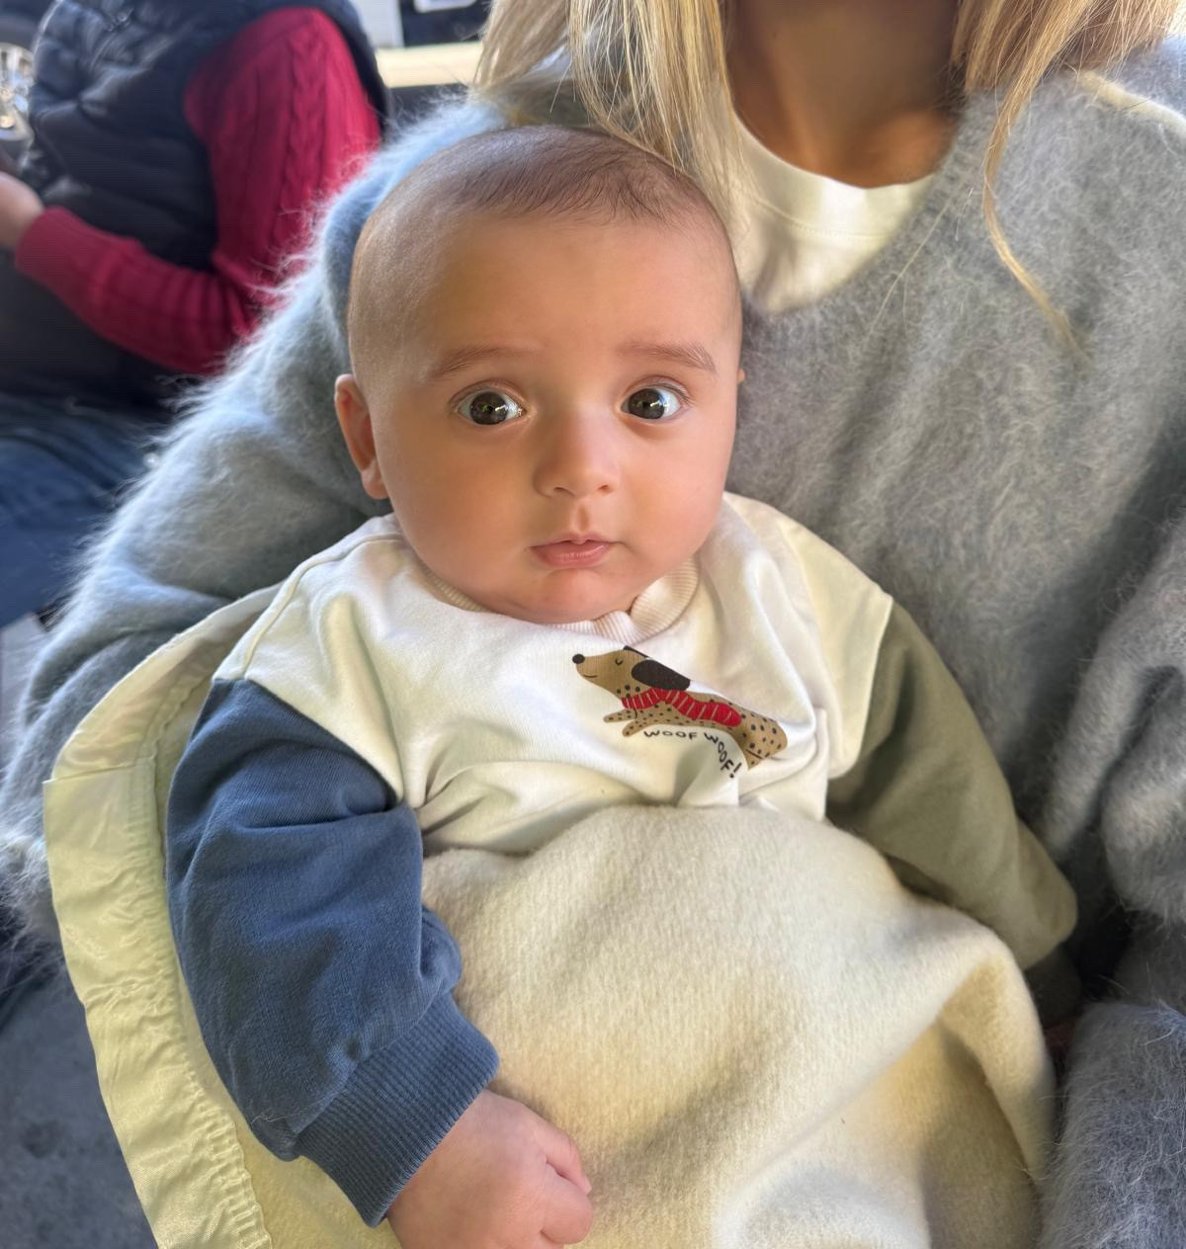  Lily Tribe (Langford, 2014) and son Rupert, born on 29 December 2025 | 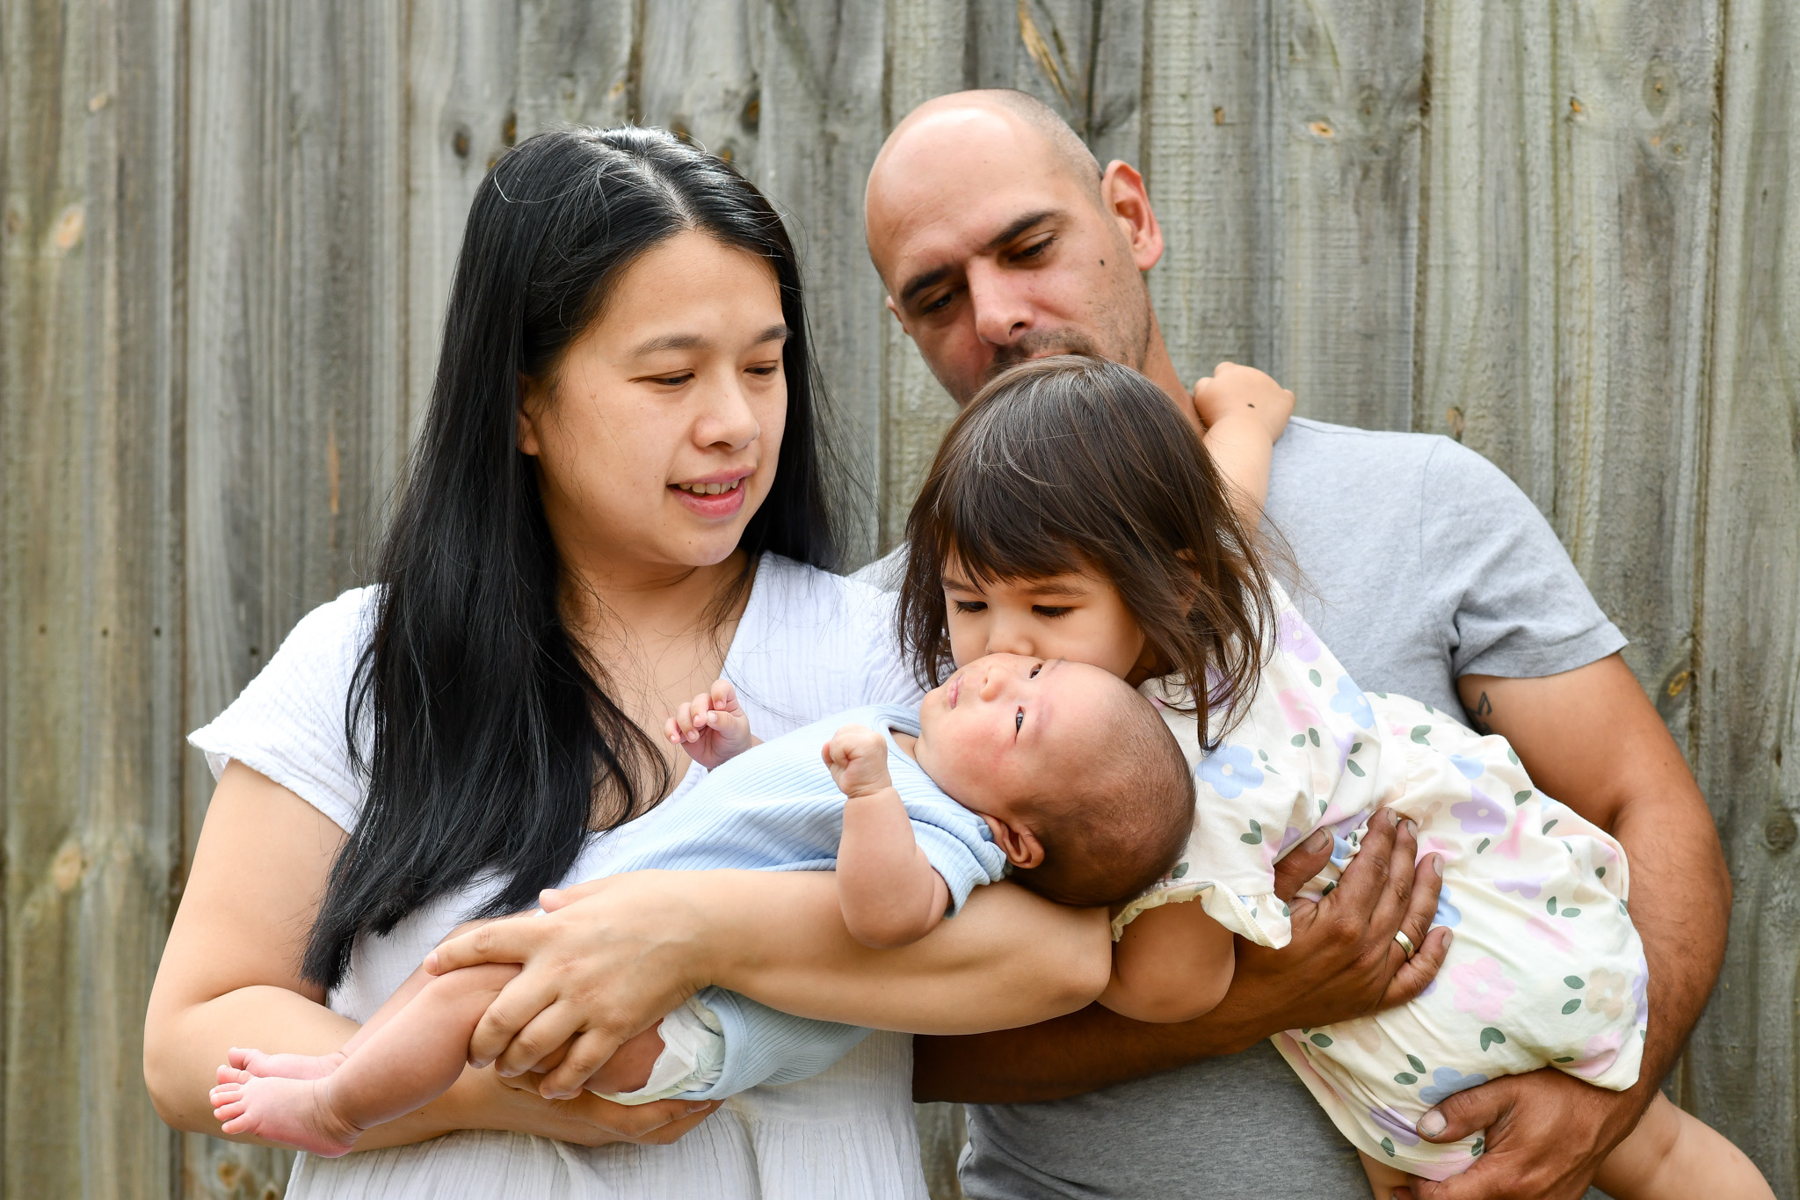  Elisa Huynh (2006) with her son Spiridon Duc Georgiou, born on 29 December 2025 | 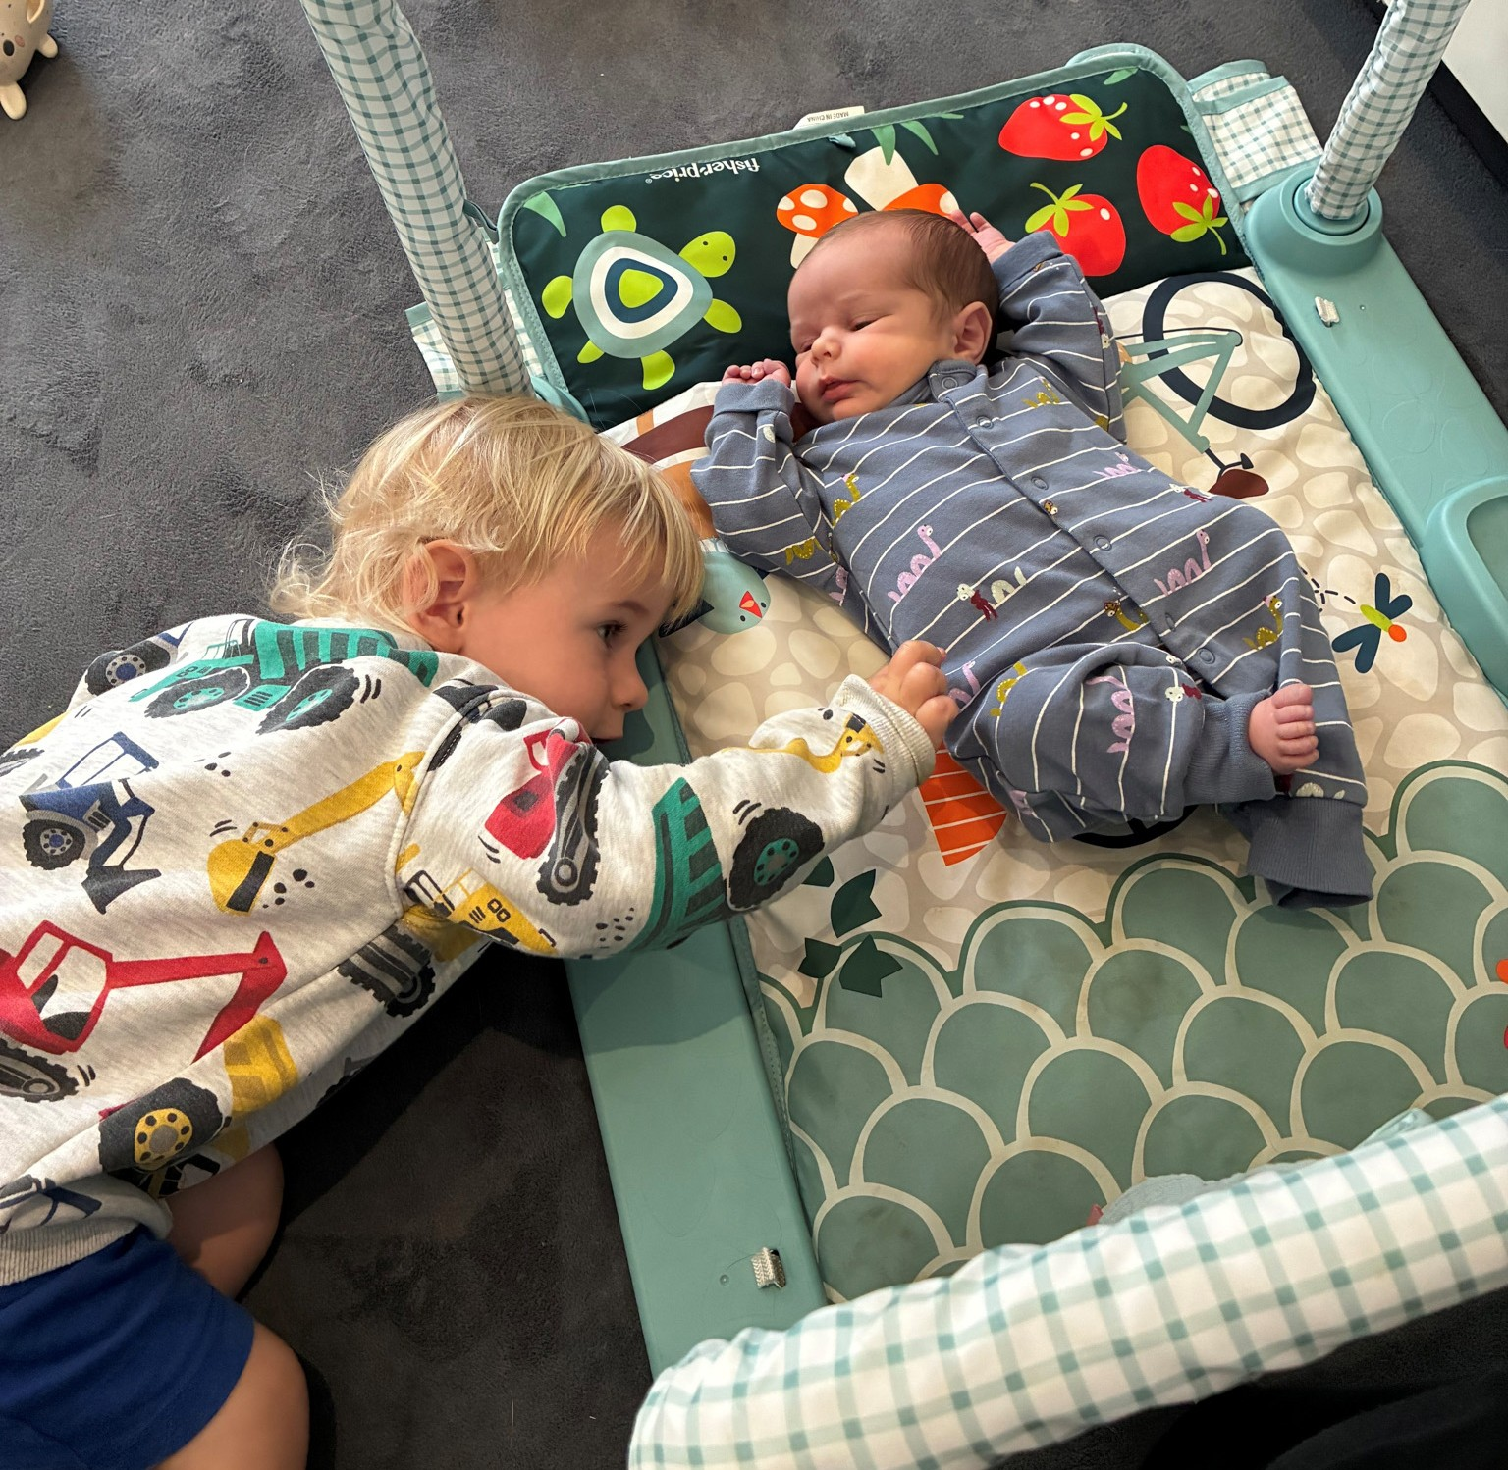  Lucy James' (2012) sons Rupert and baby Fergus Christopher McLeod, born on 23 February 2026

Engagements & Marriages
- Annabelle Aitken (2016) married William Harding on 31 January 2026 at St Peter’s College Chapel, with a reception at Penfolds Magill Estate Kitchen. Her Matron of Honour was Heidi Ashcroft (née Duthie-Hillebrand, 2016), whose wedding took place on 22 November 2025, where Annabelle was Maid of Honour.
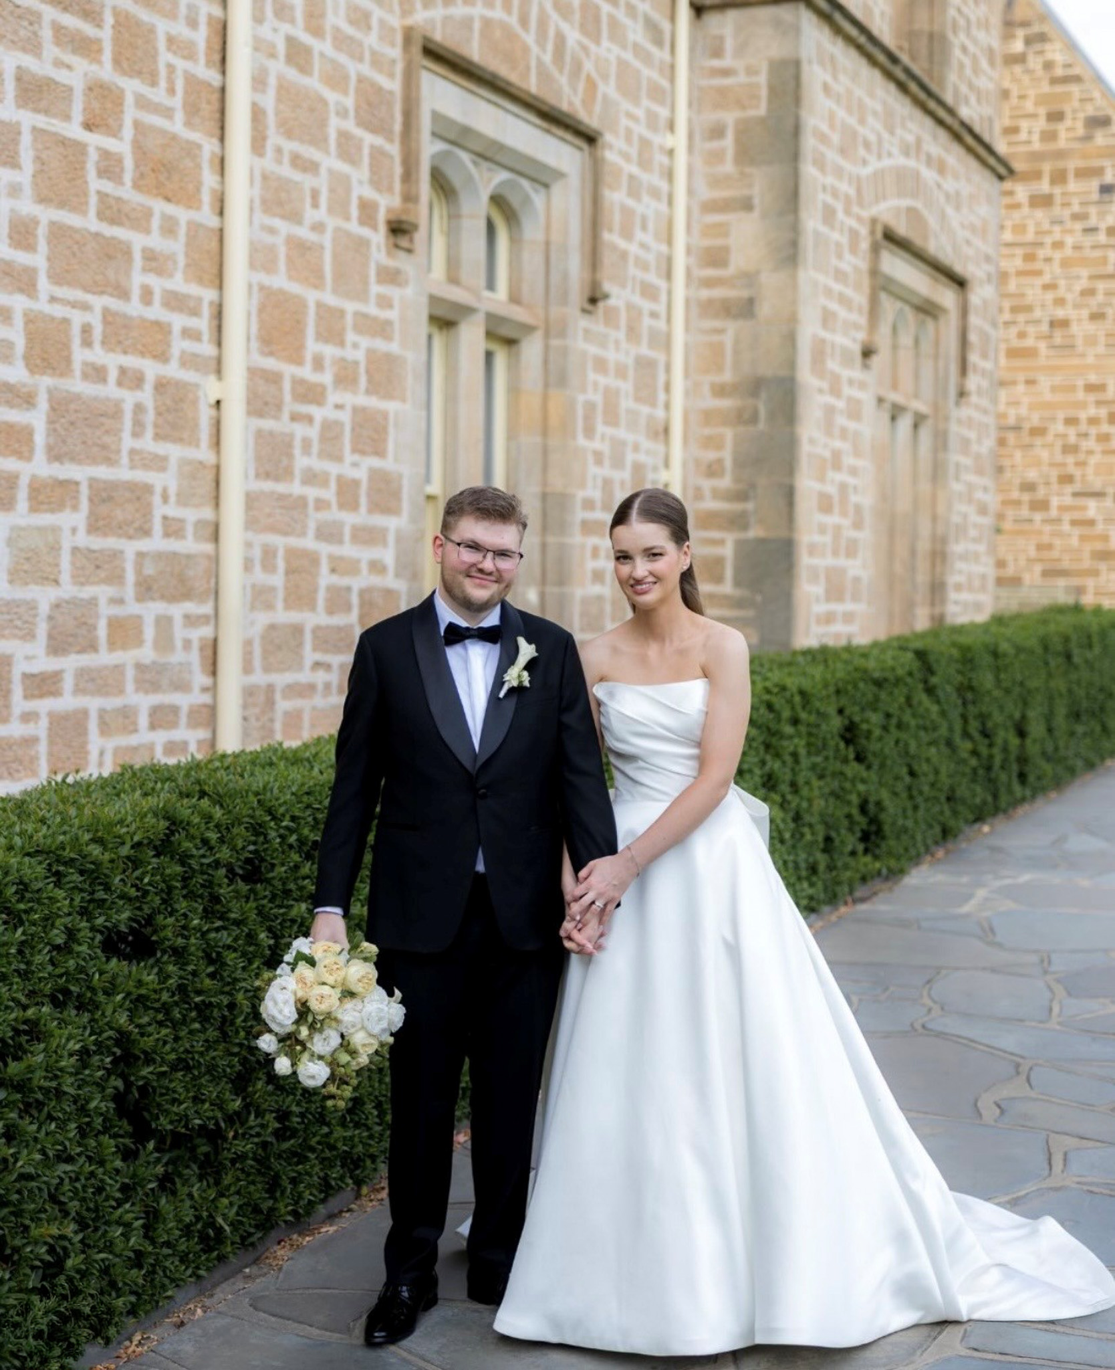
Annabelle Aitken and husband William Harding

Vale
Acknowledging, celebrating and paying tribute to the women who make up our Melbourne Girls Grammar community is important to us. Graduates of Melbourne Girls Grammar and other community members have gone on to do incredible things with their lives.
If you'd like to pass on an obituary for an Old Grammarian or past staff member for IE, please email community@mggs.vic.edu.au.
- Professor Katie Allen AO (Stephens, 1983) 24 February 1966 – 23 December 2025
- Audrey Kelso (1985) 9 June 2024
- Helen Gerber (Hughes-Jones, 1953) 19 September 1936 – 29 January 2022
- Isabel Anne Stogdale (Patterson, 1944) 26 October 1926 – 9 December 2025
- Shirley Poulton (Croome, 1945) 1929 – April 2026
‍

Vale photo gallery
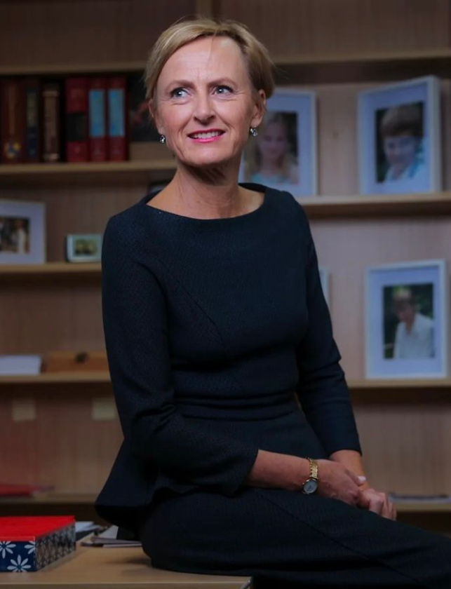  Professor Katie Allen AO (Stephens, 1983) | 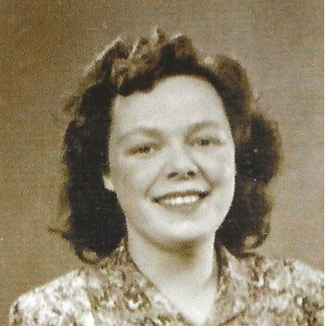  Shirley Poulton (Croome, 1945) | 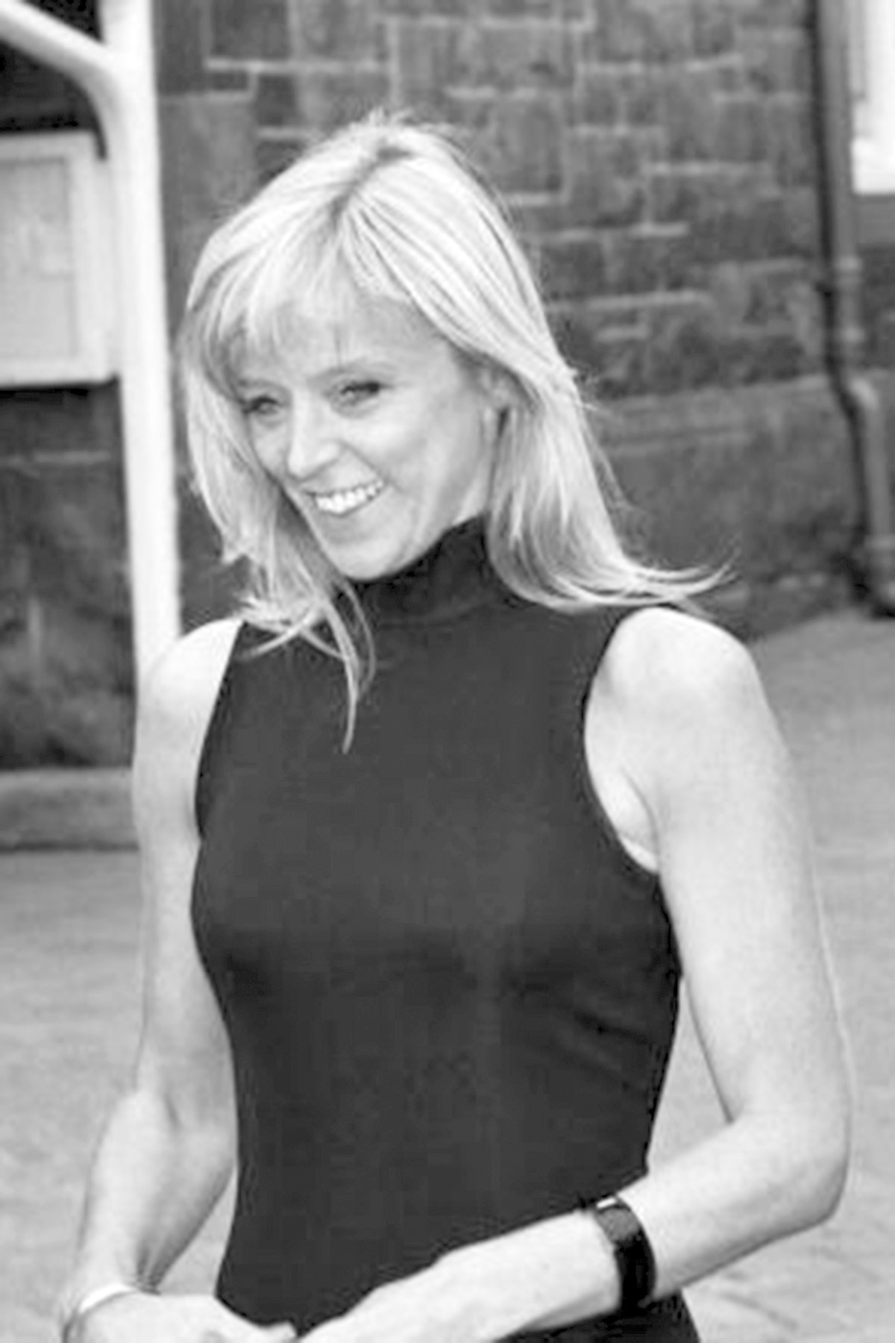  Audrey Kelso (1985)

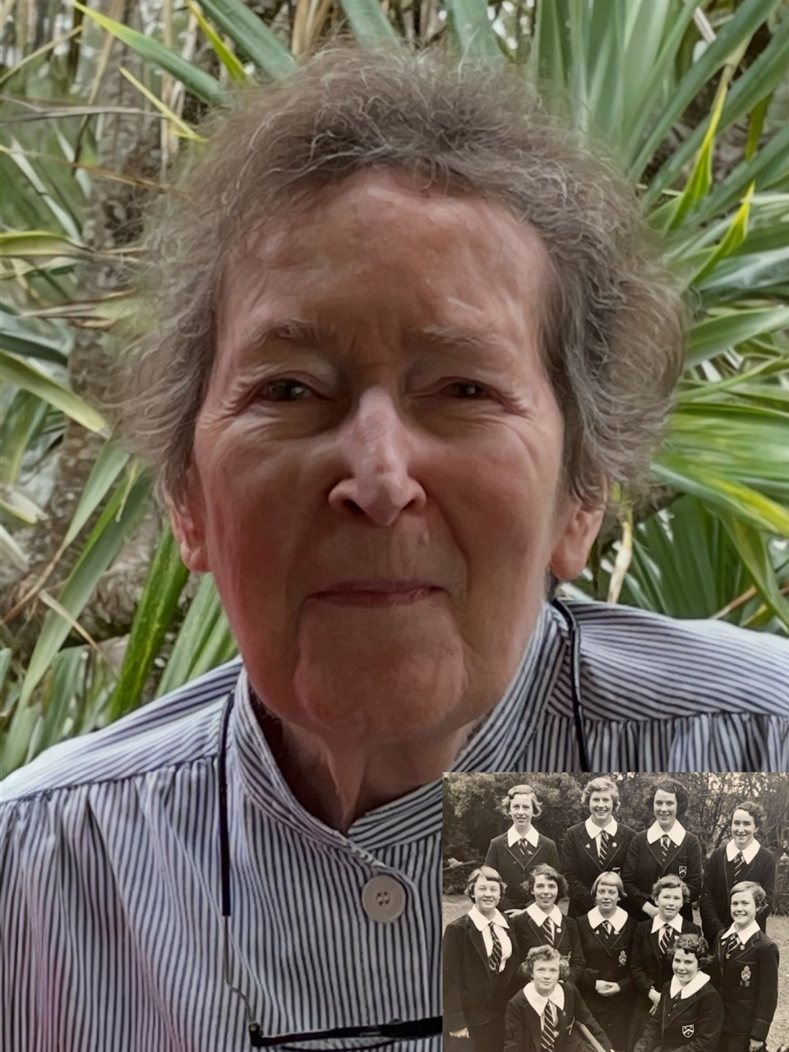  Helen Gerber (Hughes-Jones, 1953) | 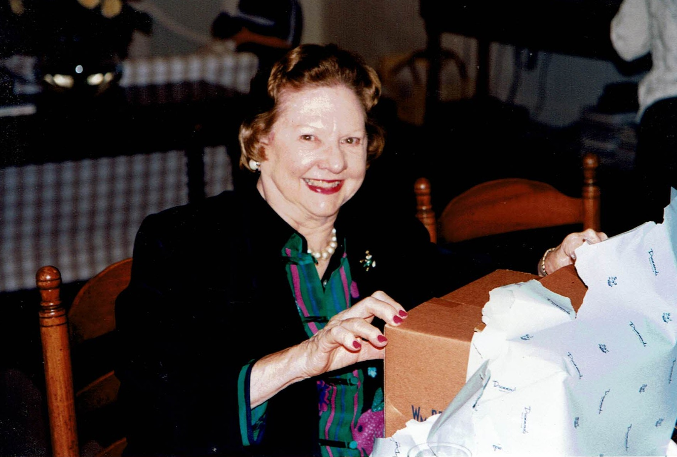  Isabelle Stogdale (Patterson, 1944)

Obituaries and Tributes
Professor Katie Allen (Stephens, 1983)
On 29 January, MGGS played a significant role in farewelling much-loved alumna, Professor Katie Allen at St Paul’s Cathedral. Our 2026 SEC were ushers, and our Chamber Voices Choir led the singing of the School Anthem.
Dr Toni Meath was one of the speakers at the moving memorial service. Below is the tribute she wrote, and read, on behalf of the School.
Melbourne Girls Grammar has lost a champion, and we gather today to celebrate Katie’s life. In our School community, Katie was a brave alumna and ally who was a constant. She advocated for girls in education and helped to consolidate a vision of excellence at MGGS that reflected her own brilliant engagement with the world, uplifting girls and caring for our community in a way that was real and positive.
Indeed, across the many communities Katie was a part of throughout her life, there is profound grief and sense of loss and disbelief that someone so brilliant and so committed to advocating for her community is no longer with us.
Katie made her mark early and served her country with excellence. She was a true Grammarian, a very much-loved graduate of Melbourne Girls Grammar. She was ours! We are so very proud of her contribution to the fabric of our School, and to Australia and the world.
Moving from her home in Albury, Katie joined MGGS in 1980 as a boarder in Year 9. She settled into School life, with a keen interest in music, sports and schoolwork. In year 10 Katie held the position of Form Secretary, joined the debating team and was a member of the Music Committee. She excelled at the Goethe Competition and proudly represented Victoria in the 1981 Australian Secondary Schools Water Polo Championships, held in Perth. In Year 11, her focus on her studies saw her receive awards for Excellence in both Mathematics and Greek and Roman Literature. At the end of Yr 11 Katie went on a Classics tour to Italy and Greece organised by the School and it made a huge impression on her – she loved the multidisciplinary nature of studying Classics, beyond Latin alone. She would often turn to Classical philosophy to rationalise difficult decisions in her future career.
In 1983, her final year at school, Katie’s leadership qualities had come to the fore, and she held many roles of responsibility; Mungo House Vice Captain and Swimming Captain, she was on both the Music Committee and the Debating Committee, was a Boarding House Councilor, won the Senior Swim Shield and achieved Grade 8 AMEB in piano. Later in discussing School Katie loved madrigal singing and would play the piano competently for the rest of her life. In her final year of School Katie also received the Wales Maths Competition Award, and already knew medicine was her future although Katie could just as easily have taken up a career in the humanities or law.
What you will have noted from Katie’s amazing school career is that she was a polymath. Her brilliance across many subjects came naturally but was always enhanced by her integrity and self-discipline. In the School records, Katie is described as a brilliant and engaged student, ‘highly motivated to achieve and very well organised’, ambitious, responsible and gifted. This all sounds rosy, however at Speech Night a few years ago Katie spoke about failure and about all the times (at School and in her career) when she put her hand up for things and didn’t achieve them. Her ambition and enthusiasm could overwhelm her ability and situation. With every failure she became more focused. Her honesty and candidness were inspiring.
It is no surprise that Katie turned initially towards medicine, a career that combined many talents, while also allowing her to express her deep care and advocacy for others. These were the traits that underscored her brilliance and revealed a pattern of being compassionately engaged in the world around her.
Katie’s family has over 100 years of affiliation with MGGS. Katie’s mother, Judy Stephens and grandmother Daisy Morris attended MGGS. So did Katie’s sister Penelope, her cousins and her nieces. Sadly, Katie lost her mother at an early age and there are alumnae here today who were dear friends of her mother who stepped in as central figures for Katie throughout her life. Katie’s two daughters Jemima and Arabella attended the School, the fourth generation of women in the family to do so, and so Katie returned as a mother to Merton Hall, invested and engaged in the life of the School. Katie commenced on the MGGS School Council in 2015 and as Chairman led the Council with distinction before stepping down so that she could focus on Politics. She was instrumental in the development, fundraising and implementation of our Artemis Program, a unique internationally recognised program and building dedicated to the health and wellbeing of girls and young women.
Katie was a brilliant mentor and positive role model. She recognised the potential in others and actively supported them to be their best selves. It is difficult to quantify just how many people Katie has mentored as her generosity of spirit and capacity for others was so large. She was an excellent active listener and an experienced and trusted confidante and advisor to many. Katie helped her mentees navigate challenges, develop their skills, set goals, seek opportunities when they arose and build their own personal networks. She used her influence to promote causes especially those of women. Katie was a catalyst, a connector. Several promising medical students reached out to Katie for advice on leaving school and how to get into medicine – she mentored them through the admissions and interview process, and several are now promising young medical students.
Her work with The University of Melbourne’s Pathways to Politics Program for Women was a great passion. Katie encouraged others to take on political leadership in a bold and courageous way. She was instrumental in actively taking those from the program to Canberra and ensuring that they had as much exposure and conversation with political colleagues as possible. Katie wanted more women in politics, and she said openly that there was no greater way for her to serve her country that to represent its people in parliament. Katie’s final flight three months before her death was with ten promising women from Pathways to Politics, taking them to Canberra for two days immersion in the political milieu and giving them real-time guidance on what they saw and heard.
In the words of one of her young mentees, former School Captain and Grammarian, Ahelee…
“I had the extraordinary privilege of receiving Katie’s mentorship over the years. We would meet for coffee, I interned for her in Canberra when she was a Member of Parliament, she would attend my family’s Eid celebration each year. Receiving Katie’s guidance and support as I finished school and started university was truly the greatest gift. She had an unrivalled generosity of spirit – once she took you under her wing, she took it as a personal responsibility to support, nurture and guide you into the person she believed you could be – and in doing so, has helped shaped me into the person I am today.”
Katie was good at so many things, such as she knew quintessentially how to ‘play the ball, not the person’. A true diplomat! She loved the contest of ideas and would thoroughly debate on anything she was passionate about. At MGGS we use a phrase ‘the pleasure of the rigour’. Katie loved that – she totally understood the delight and simple pleasure of doing something challenging and succeeding. Katie was a great consensus builder and I observed her closely in meetings, bringing people with disparate thinking together. She knew how to appeal to a person’s sense of good judgement and could disagree without offending.
Katie could build a formidable team, and I am honoured to be part of ‘Team Katie” when she chose me to be the 12th Principal of MGGS. We shared the same vision, courage, commitment and confidence that we could achieve extraordinary things for MGGS. Last year was a record year of achievement for our School in all metrics!
Katie was a frequent visitor to the School, and we would meet regularly to discuss our Grammarians. She spoke often at Assemblies, both at Morris and Merton Hall, at Speech Night and at School gatherings. As President of the Merton Hall Foundation, she was active in fundraising and ensuring that the Foundation had a contemporary lens. Her love for Melbourne Girls Grammar was palpable!
You can tell much about a School by its silverware. The trophies and awards that are given over time and what is paid attention to, what is treasured. We have two for Katie’s family. The first is the Allen Family Cup also known as The Stephen’s Cup, dedicated in memory of her mother Judy for the much-revered and loved Annual House Instrumental Competition, and the other the Annual Professor Katie Allen Oration Award for Public Speaking. Katie was an exceptional and compelling public speaker, and this Award is perfect in her name. Katie was at our most recent Speech Night to listen to the inaugural recipient deliver her oration on “Why Teachers Matter”.
Katie’s career was marked by exceptional accomplishments, but her family was her greatest joy. Our heartfelt sympathy to her husband Malcolm, and children, Monty, Jemima (OG 2017), Arabella (OG 2019) and Archie, and to her first grandchild and extended family.
At MGGS we create ethical women of action – Katie was exactly that – a fierce, brilliant and engaged advocate for girls and women. Generations of women will live stronger because of her. It is said that one never dies when one’s name is still recalled. In the hallowed halls of Merton Hall, dearest and brilliant Katie you will live forever.
Written by Dr Toni E. Meath, Principal of MGGS
‍
Audrey Kelso (1985)
It is with great sadness that we announce the passing of our sister, Audrey Kelso (1985), on Sunday 9 June 2024. Audrey lived with lung cancer for five years, and in the final three years of her life, the cancer metastasised to her brain. Audrey had a highly successful career as a Senior Business Analyst in the IT industry, in which she worked for over 20 years. She was known for her strong work ethic and her tireless commitment to delivering excellence in every project she undertook. Audrey loved her dogs and family wholeheartedly. Although she did not have children, she is survived by her five siblings – Richard Kelso, Debbie Kelso, Andrew Kelso, Stuart Kelso, and Michelle Kelso – as well as her mother, Maggie Kelso. Audrey will be forever loved and deeply missed.
‍Written by Michelle Kelso (1981)
‍
Helen Gerber (Hughes-Jones, 1953)
Helen moved from Melbourne to Brisbane with her husband and two small children in 1963. A third child came along later that year. She started her working life as a social worker, but put her career on hold for many years to care for her family and children. Helen lived her life completely selflessly, and towards the end suffered with a number of very challenging health issues. Helen or ‘Hughsie’ as she was still often called, was the most stoic, resilient, fun loving and beautiful person. She is deeply missed every second of every day.
‍Written by Daniela Gerber
‍
Isabel Anne Stogdale (Patterson, 1944)
Isabel Anne Patterson was born on 26 October 1926 to Gerald and Ormé Patterson at Mernda, the family house in Kooyong. Her mother, Ormé, was formerly a Riggall of East Gippsland. Isabel was the youngest of two children, her older brother was Gerald William Riggall Patterson, known as Bill. Bill was better known as a racing car driver and MD of Bill Patterson Motors in Ringwood. Her father, Gerald Patterson was a world-famous Tennis player, having won the Championships at Wimbledon, twice (1919 and 1922) and having won a Military Cross at Messines in 1917. Gerald was also Dame Nellie Melba’s nephew. Gerald’s mother Isabella Ann, was Melba’s sister. While Gerald’s Tennis playing days were largely over by the time Isabel was born, he continued to support Australian Tennis by being coach to several successful Australian Davis Cup teams. Gerald was the founding chairman of Bill Patterson Motors, having acquired the GM franchise for Bill in the late 1950’s. This would be a shared family business until the middle of the 1970’s when the family sold out. Pre WW2, Gerald and Orme acquired Kimotho, #6 Landale Road, but during the War moved to their newly built house in Orchard Lane Mt Eliza, allowing the visiting US forces to use Kimotho as accommodation for senior officers. Isabel was educated at Little St Margarets and Melbourne Girls Grammar. After the war, in 1947/8, she toured Europe with her friend Betty Nicol, driving across France and the UK.
In 1951 she married George Stanley Arthur Stogdale, who was a former POW of the 8th Division who had been one of the many that constructed the Thai – Burma railway (the death railway). He returned to Australia in late 1945 and had moved to Melbourne with McDonald Hamilton. Originally living in Avenel Road Kooyong, Isabel and George bought #10 Rathmines Street Toorak in 1960 and the family lived there until George retired in 1983, due to ill health. In 1955 my brother George was born and I turned up at the end of 1959. As a family, we lived a modest life in spite of the address. We were lucky that Mum’s mother, Ormé had bought a nice holiday house in Yamala Drive, Frankston in the 1960s for the family. This allowed a place to ease off the pedal for a few weeks a year.
My Father, George had been diagnosed with Prostate Cancer in 1982 and this was one of the reasons for his retirement and their move to Sydney. George was in remission until early 1987 but passed away at the end of 1987. In 1989, Mum visited and stayed with me in London as part of a three month grand tour, including attending the Men’s Final of Wimbledon and representing her father and the family at the posthumous induction of her father, Gerald Patterson into the International Tennis Hall of Fame at Newport Rhode Island in the USA. A lifelong dream of flying on Concorde was part of that trip. Mum had a close-knit group of mates in Sydney where she would catch up at either the Royal Sydney Golf Club or the Rose Bay Surf Club.
She also hosted New Year’s Eve parties at her apartment for many years, until it all became a bit too much. In Sydney, she was living her life and enjoying it immensely. But as COVID created travel issues she was finding the isolation of where she was to be not what she wanted. As a family we agreed to return Isabel to Melbourne mid-2022 and that the Sydney flat would be sold later that year. By mid 2023, Mum moved into care and we were lucky to have her in the Emerald Hill residence in South Melbourne. Mum passed away peacefully on the evening of Tuesday 9 December 2025. She was the spark at a party. She had a quip for almost any situation. However, she did not suffer fools gladly. She was also determined to have her life once she was able to. In this she surely succeeded. As a mother, she was firm but loving. One could not ask for much more. She will be missed by our family forever.
Written by David Stogdale
‍
Mary “Shirley” Poulton (Croome, 1945)
Shirley Poulton died in April 2026, at age 97, in the UK. Shirley, like other girls from many places during the Second World War, moved to Australia with her parents. They came from England, while others came from places such as Malaysia and Singapore. The trip to Australia involved a long boat trip in those days, passing through the Suez Canal and, as it was war time, was not without risk. Shirley attended Melbourne Girls Grammar from 1940 to 1944 while her father worked at Fishermen’s Bend as an engineer involved in making aircrafts such as Bristol Fighters and Bristol Beaufighters.
An extract from Simon Poulton’s (Shirely’s oldest son’s) eulogy:
“It was a sign of wartime that their departure back to England in 1944 was shrouded in secrecy. Shirley knew nothing of the return until it happened, for fear of her saying something at school. Shirley’s mother and the headmistress agreed Shirley would just leave at the end of a school day and not return!” They had to wait six weeks in South Africa before being able to travel in a Navy convoy through the Atlantic. D Day was announced while on that trip.
Shirley made many friends at MGGS who she kept in touch with over the years, sending news of marriages, births and children back and forth. My mother, Prue Stoney was one of Shirley’s friends. When my mother passed away many years ago, Shirley and I continued to exchange Christmas cards and news. I visited Shirley many times in England, both in Ruislip in Middlesex and Offwell near Honiton in Devon, and enjoyed her family’s hospitality. More recently, I visited her in Beaconsfield, England where she was living in a lovely unit. After leaving school in England, Shirley studied at The West of England College of Art in Bristol, gaining a Diploma in Design and an Art Teachers Diploma. She taught art in schools for many years. She also enjoyed painting and I was able to view many of her wonderful paintings, many of them of flowers. This was something she had in common with my mother who also painted flowers.
Later in life, Shirley and her husband Peter had an antiques business in Devon. In 1995 Shirley returned to Australia for six weeks, visiting her school friends. She stayed with my family for a number of days. I took her to see the places she remembered, her homes in Avoca St (South Yarra) and Camberwell, as well as the Botanical Gardens and the NGV. We visited Melbourne Girls Grammar and she was amazed at the changes. During this visit, she caught up with Clarissa Starey (1946), another Old Grammarian, who was living in Geneva, had worked with the Red Cross and was then the Women’s Representative on the UN for the Asia Pacific. I drove Shirley up to Hay to visit another of her school friends. Sadly, this group of friends have all passed away with their memories of Melbourne Girl’s Grammar and life during WWII.
‍Written by Dr Jenny Woods (Prue Stoney’s daughter) fromher talks over the years with Shirley and her son Simon’s eulogy.

Australia Day Honours
Anne-Catherine (Kate) Thompson (1961) OAM
Anne-Catherine Thompson was awarded a Medal of the Order of Australia (OAM) in 2024 for service to modern pentathlon – a five-event Olympic sport.
Ms Thompson has been secretary/director of Sport at Modern Pentathlon Victoria since 1997 and was made a life member of the organisationin 2019.
Her previous roles at Modern Pentathlon Australia include vice-president for 10 years, and Australian director of sport and high-performance manager from 2001-2013.
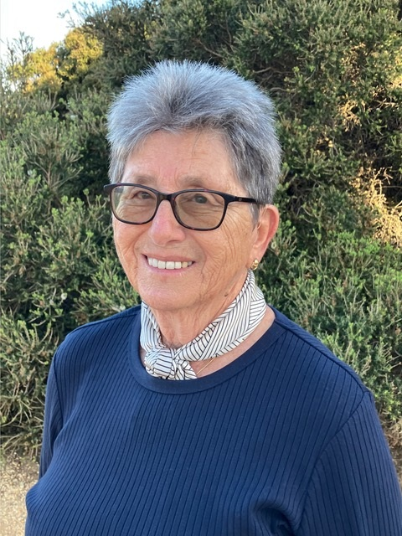
Anne Catherine (Kate) Thompson (1961) OAM

King's Birthday Honours
Professor Katie Allen (Stephens, 1983) AO
Professor Katie Allen (Stephens, 1983) posthumously appointed an Officer of the Order of Australia (AO) for service to paediatric allergy and gastroenterology research, and for her service to people and federal parliament as the member for Higgins. Katie Allen was an esteemed alumna, former Chair of the School Council, and President of the Merton Hall Foundation. Her passing late last year drew an outpouring of grief from the wider community, and the School continues to honour her lasting legacy. One of the ways she is remembered at MGGS is through the ‘Professor Katie Allen AO Oration Prize’ awarded to a Year 9 or 10 student each year, with the winner’s address delivered on Speech Night.
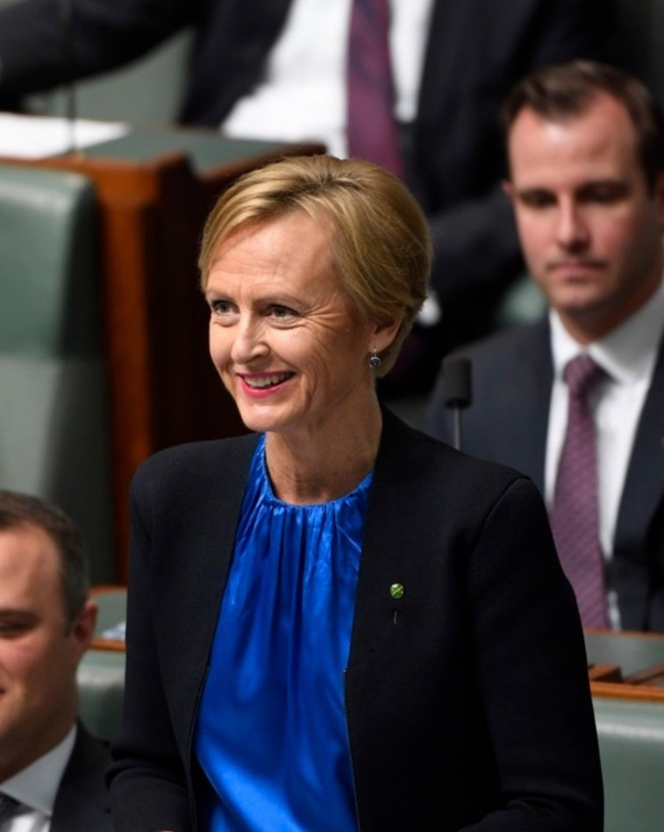
Professor Katie Allen AO (Stephens, 1983)

